**ASSESSMENT PORTFOLIO**

**SC1153: Introduction to Biotechnology**

Sri Lanka institute of Information Technology

New Kandy Road

Malabe

9.1th Batch: October 2023 to January 2024

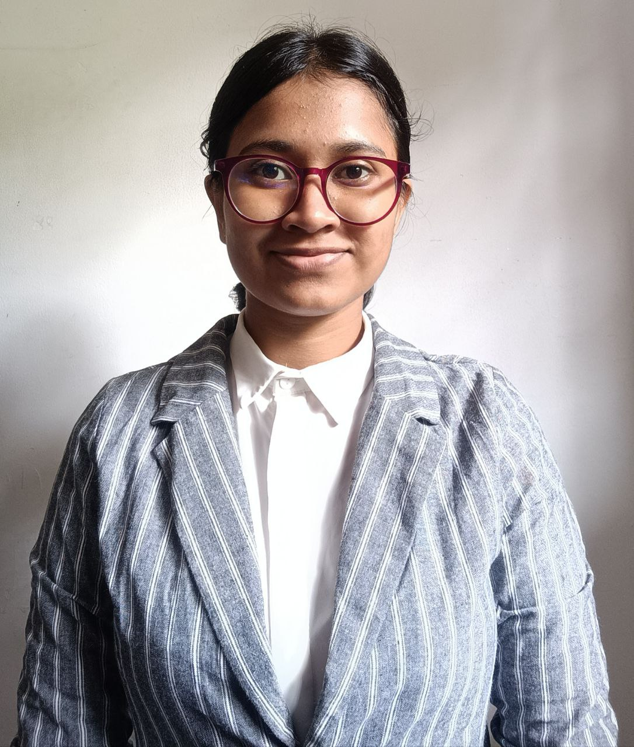

Name: W.S.U.Kularatne

HS23747104

**Abstract**

A structured assembly of a student's work, showcasing their accomplishments and participation over time, aiding in the assessment of their learning progress. It serves as a mirror for students to see their own growth. It fuels their motivation and provides valuable insight to the lecturer about the areas where a student excels or needs improvement. As we come to see about the quiz one it is a MCQ question paper with 15 MCQs it’s about fields of biotechnology. I got to know many things regarding fields of biotechnology. The assignment one was a group presentation on a selected area of biotechnology. It is to explore various type of biotechnology. I was in six group with other 5 students. Our group presentation was about food biotechnology and we chose the title as “NEW ERA OF FOOD NUTRITION”. We discussed about some meaningful areas of food biotechnology. New innovation of food biotechnology was the part I presented. The assignment two was create a video about a new product. Our group chose to talk about Bioplastic. I presented about bioplastic production, biodegradable and non-biodegradable bioplastic. From this assignment we learn how to make a video presentation. Assignment three was Talk show on ethical aspects of a selected applications to make an awareness. As we were group seven our topic was aged care. My role was a lawyer and I contribute my part on describing the laws and regulations on aged care. From this talk show I develop confidence to talk Infront of others more than other presentations. Assignment four was about cover letter and resume. Here I got to know how to make my own cover letter and resume. Assignment five was career trajectory to acknowledge about career opportunities and how to achieve it. Here we talk about my role model Molly stevens and my own career trajectory. By these group assignments I developed some skills like communication, resolving conflicts, team work and time management. I think that will be help for my future.

**Acknowledgements**

It is crucial to express our gratitude to those who have offered assistance and support throughout our journey. Initially, I must extend my gratitude to our esteemed lecturer and Head of the Department, Prof. Sriyani E. Peiris, as well as the Director of Academic Development and Quality Assurance, Prof. Colin N. Peiris. Their invaluable guidance, encouragement, and the opportunity they provided to explore this intriguing field are deeply appreciated. Their method of instruction was both kind and effective, and I am proud and delighted to have been their student. My parents, my sister deserve thanks for their assistance in encourage me. Lastly, I extend my heartfelt thanks to my group mates, friends and loved ones. Their support and the positive energy they provided during the assessment times were invaluable.

**Contents**

**Description Page No.**

1. Quiz One………………………………………….…….4-5
2. Assignment One……………………………………......6-11
3. Assignment Two…………………………………….....12-16
4. Assignment Three…………………………………..….17-19
5. Assignment Four……………………………………….20-23
6. Assignment Five………………………………………..24-25
7. Assignment Six…………………………………….…..26-27
8. Reflection ………………………………………….…...28

**Quiz one**

**Introduction of various areas of Biotechnology**

* This quiz was about biotechnology introduction and fields of biotechnology. It was included medical, agriculture, marine, industrial, environment, food biotechnology etc. before quiz we learn about biotechnology areas and opportunities on those fields. we got 15 MCQs and I got 80% of marks for this quiz. I lost marks for one MCQ because of my carelessness I didn’t read the question carefully. But I’m happy for my marks.

**Objectives**

* By doing biotechnology quiz we can enhance knowledge in biotechnology, test understanding of biotech concepts, can improve problem-solving skills, can gain confidence in biotechnology topics, stay updated with biotech advancement, prepare for future biotech opportunities.

**Marked assignment**

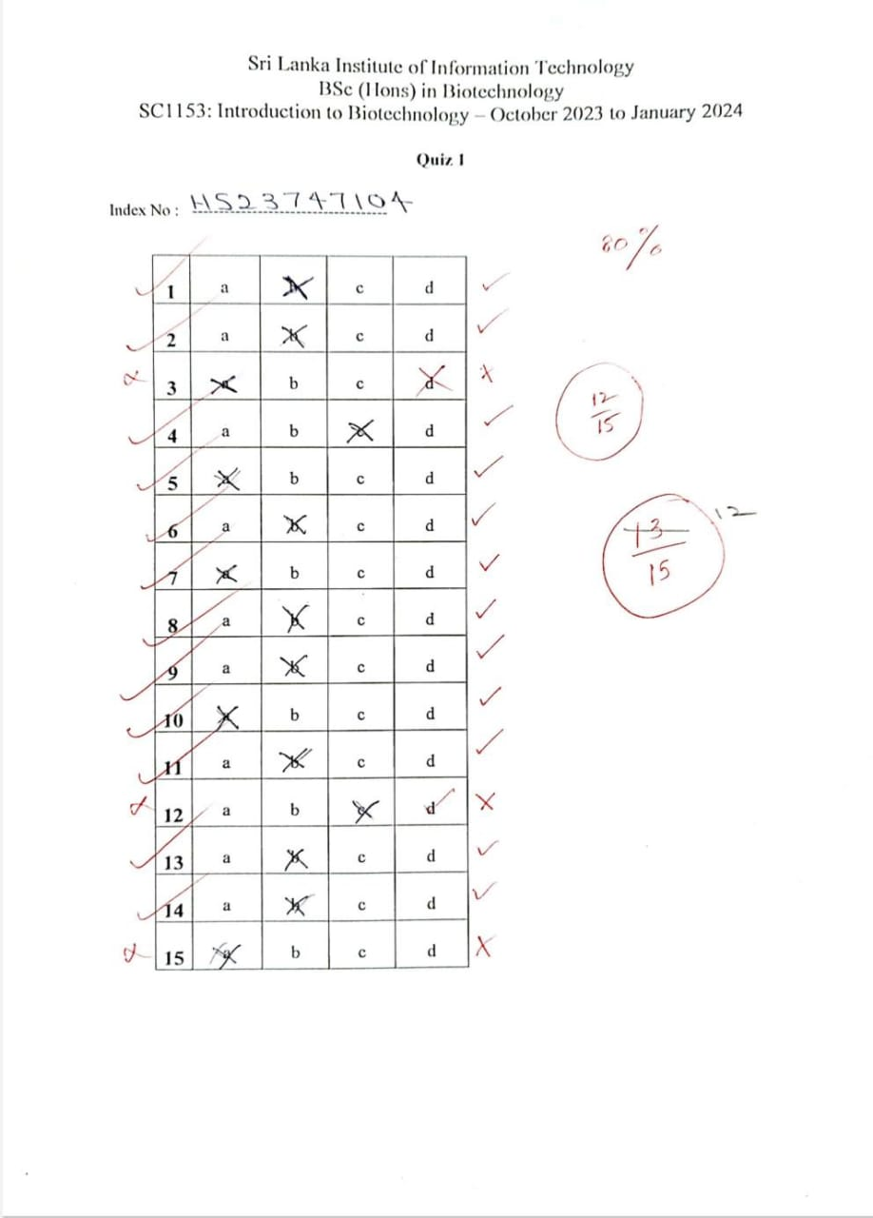

**Assignment One**

**group presentation on a selected area of biotechnology to find out the different areas of Biotechnology.**

**Title: New era of food nutrition**

Areas of Biotechnology

|  |  |  |
| --- | --- | --- |
|  | **Biotechnology Area** | **Groups** |
| 1 | Agriculture Biotechnology - plant | 1 |
| 2 | Agriculture Biotechnology - animal | 2 |
| 3. | Medical Biotechnology- | 3 |
| 4. | Environmental Biotechnology | 4 |
| 5. | Marine Biotechnology | 5 |
| 6. | Food Biotechnology | 6 |
| 7. | Industrial Biotechnology | 7 |

We have prepare a power point presentation on the given biotechnology area. Each group member should present part of it. Our title should represent our presentation should include:

**Introduction**

Introduce your subject with to motivate the audience.

**Main body**

Should have the most important information of your topic. Include the most interesting information of the topic. You should include related information which people have never heard of.

**Conclusion**

Extract the most important information you included in the presentation

**References**

Most important 3-4 citations you used to develop the presentation

**The presentation**

The presentation time is 20 minutes (one student 3 minutes)

There can be about 15- 17 slides per presentation

First slide should include the names and registration number of the group members in presenting sequence.

**Do s**

1. Present with confidence
2. Keep voice loud enough to everyone to hear you.
3. Have a good eye contact

**Don’t s**

1. Do not bring notes or phones to the presentation – marks you get will low.
2. Do not read the slides, explain the slides
3. Do not just look at the screen without looking at audience.

Presentation is on the 24th (Friday) November 2023

Upload all the presentations before 21st November 2023

Kindly note: When the group leader uploads the presentation to the course web save the presentation with Group number and assignment number.

**Objectives**

By doing group presentation can deepen our understanding of food biotechnology, enhance our research and presentation skills, collaborate and work effectively as a team, gain confidence in public speaking, educate others about the importance of food biotechnology, stay updated with the latest advancements in food technology, explore potential career opportunities in food biotechnology, footer a deeper appreciation for the impact of biotechnology on food production.

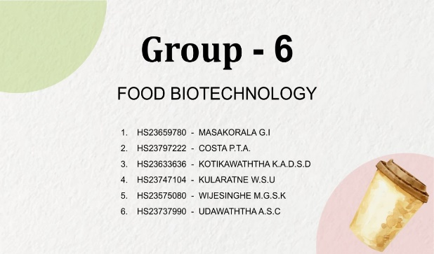

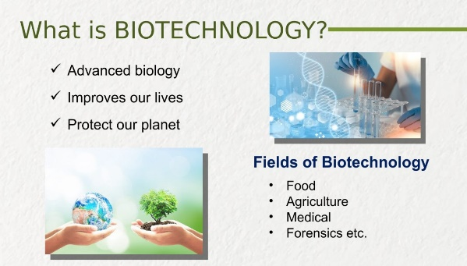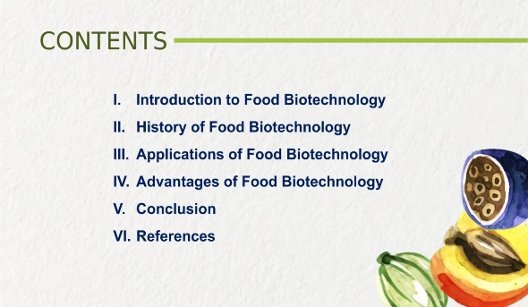

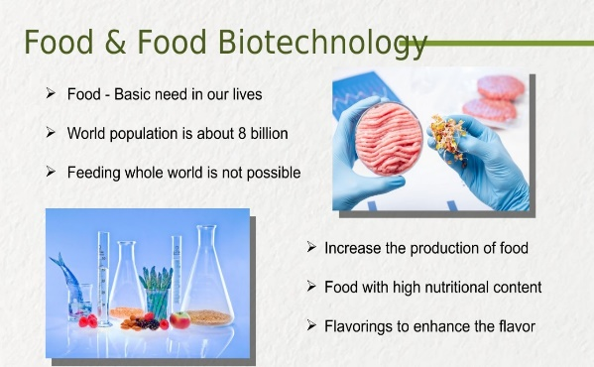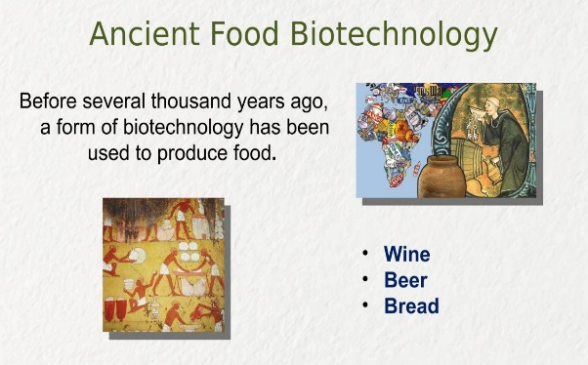

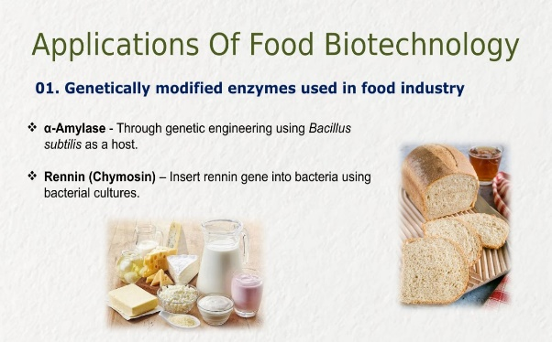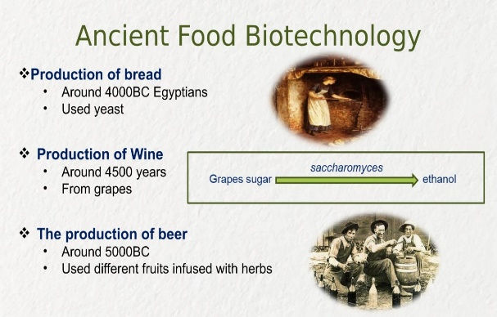

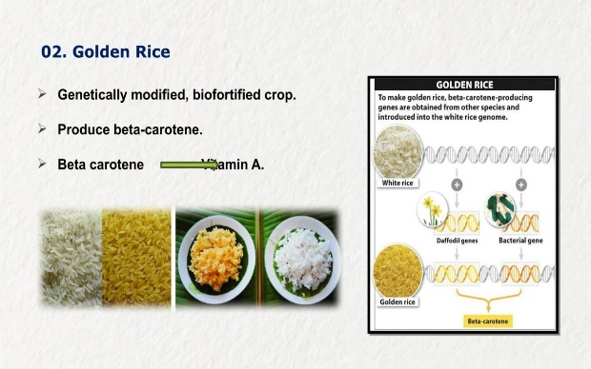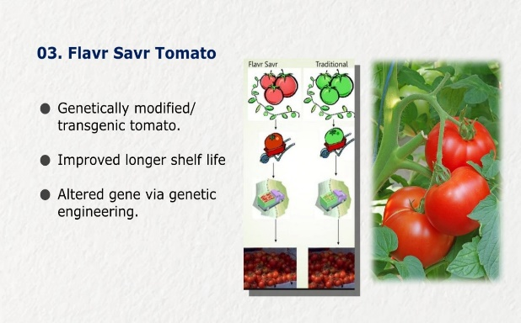

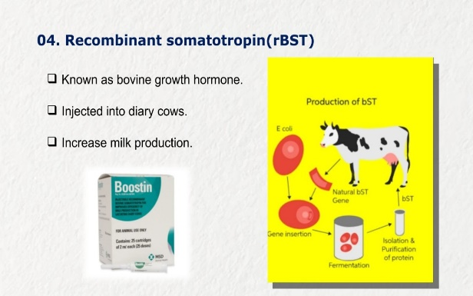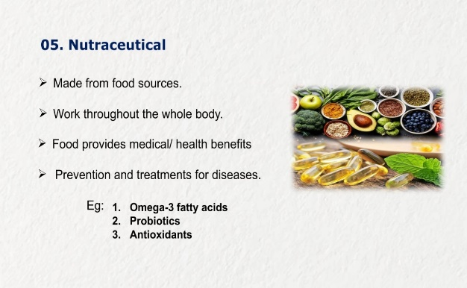

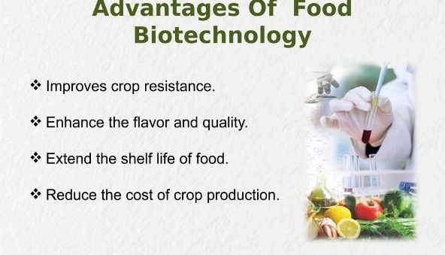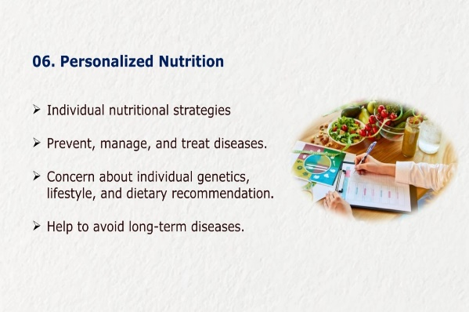

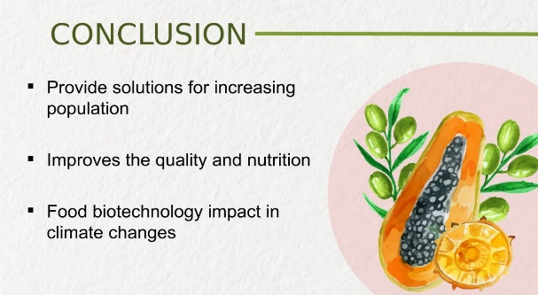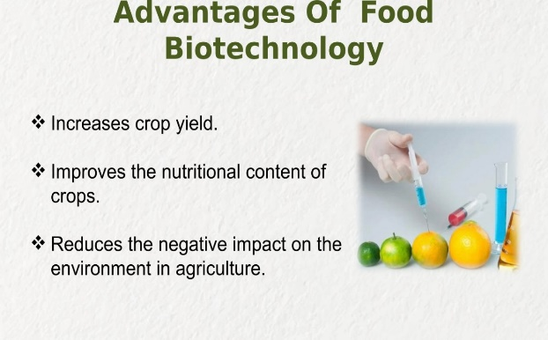

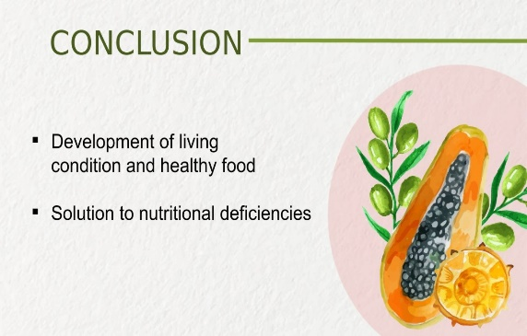

**Summary**

Our group got food biotechnology and we chose the title as ‘ NEW ERA OF FOOD NUTRITION ’ to make it more interesting and effective. Food biotechnology involves using scientific techniques to improve the production, quality, and sustainability of food. It includes genetic modification to enhance crop traits, developing new food products, and ensuring food safety through innovative methods. Food biotechnology plays a crucial role in addressing global food security, nutritional challenges, and environmental sustainability. Every member of our group did their slides by themselves. Our group leader at last merge all slides. It developed a good harmony between our group members. We tried to focus on nutrition side of food biotechnology. As it was our first presentation our groupmates including myself were little anxiety and nervous. But somehow we manage to complete it. I think our presentation was interesting to judges and classmates. Feedback from judges really encourage us to develop ourselves. I got good compliment from judges about eye contacts. From our presentation I learned improvement of food nutrition side of food biotechnology. I got 79% marks for this presentation.

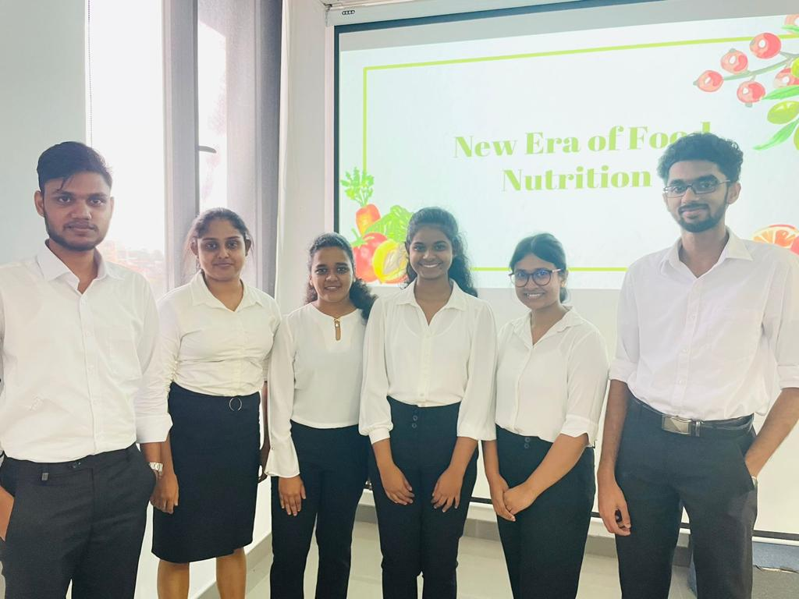

**Assignment Two**

**Create a Video to Describe a new product in Biotechnology**

**Bioplastic**

We have to Find information about **a new product in any area of Biotechnology** which has been developed using biotechnology related approach. Create a **15-minute video**. This is again a group assignment. You have to give a message to the general public through this video. You can use the software such as ppt videoing/OBS/Zoom.

We have to Use the following to develop your video

Introduction

Content

Conclusion

**The date for the video presentation is 15th December 2023 (Friday)**

Do not copy from the video available on the internet.

Two groups should not present the same thing.

Find as much as relevant information and create the video in your own style.

You will present your video in front of the academic staff members . You will add your evaluation to the portfolio.

Upload the video to the portal created in the course web (Module) on or before 12th December 2023

**Objectives**

* doing a video presentation on bioplastics can help me and Enhance my understanding of bioplastics. It Improve your research and presentation skills. It helps to Collaborate effectively as a team. It helps to Gain confidence in public speaking and Educate others about the importance of bioplastics. Stay updated with the latest advancements in bioplastic technology. Can Explore potential career opportunities in bioplastics. Foster a deeper appreciation for the impact of bioplastics on the environment.

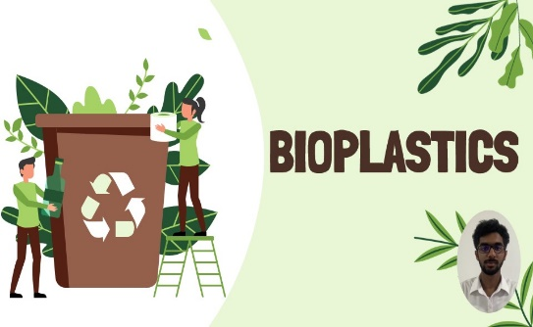 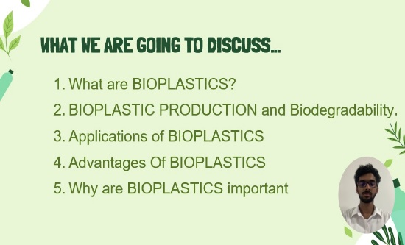

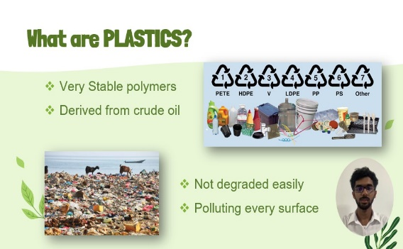 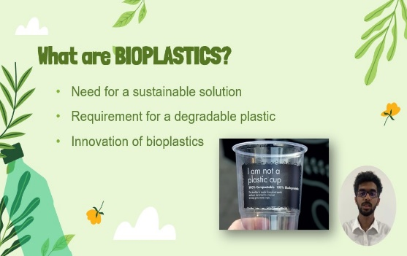

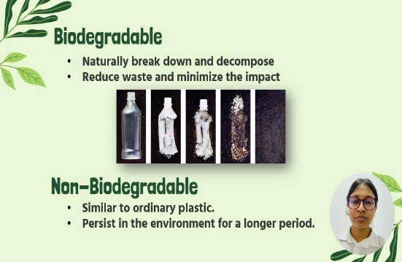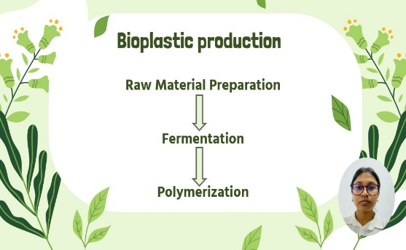

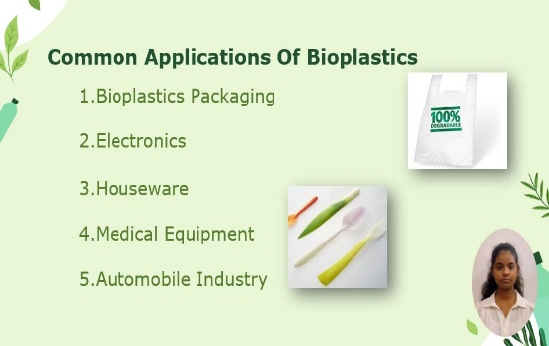 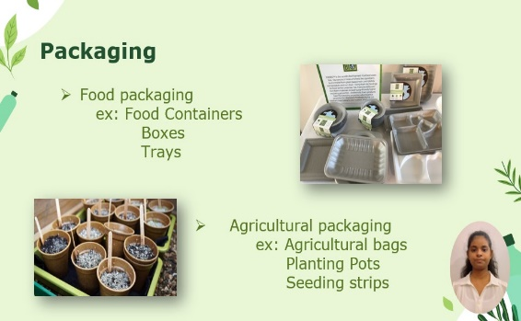

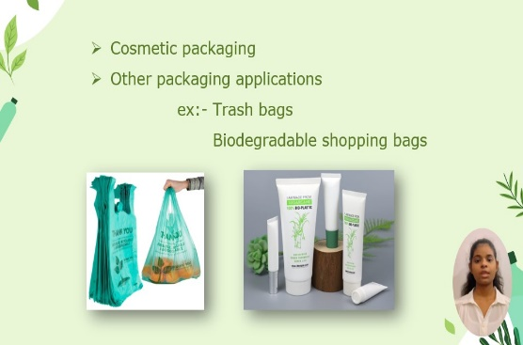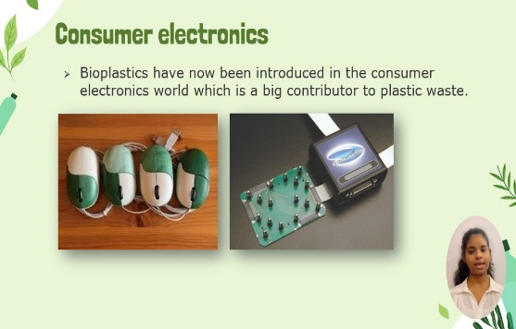

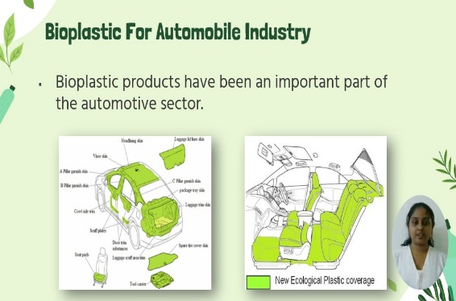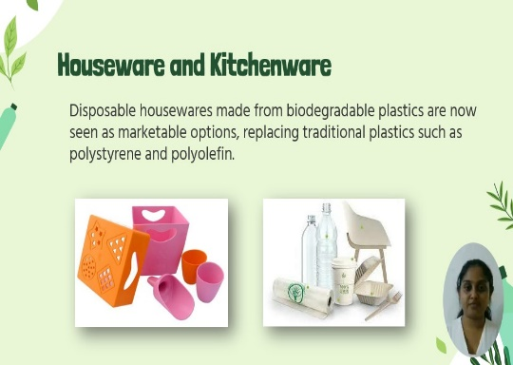

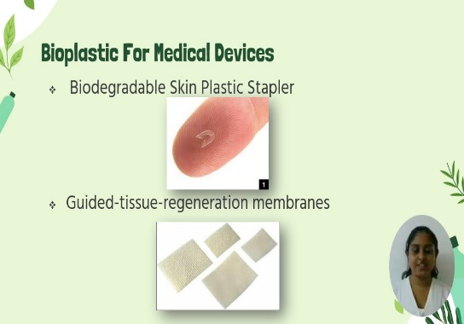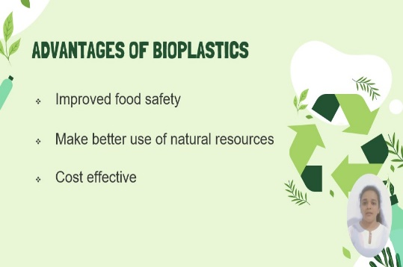

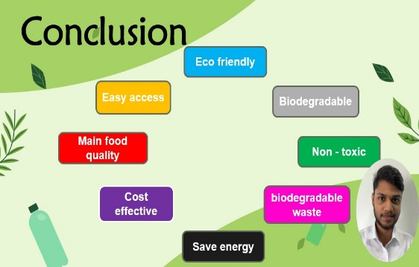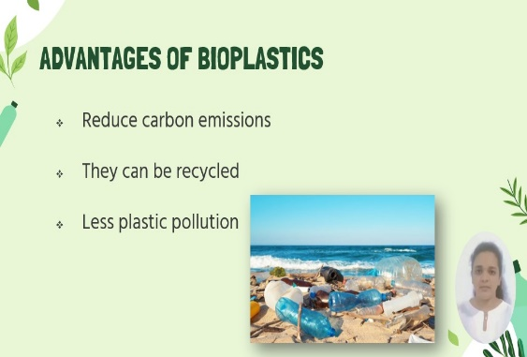

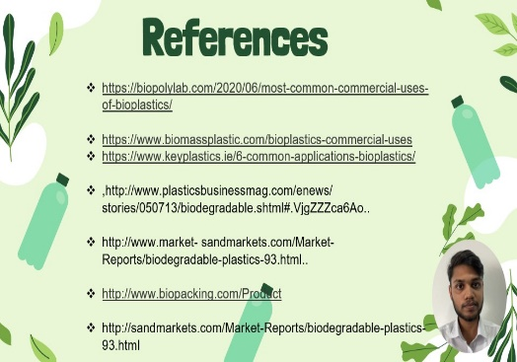

**Summary**

We had to make 15-minute video about an innovative technology or invention. We were guided by our lecturer, Prof. Sriyani. This discussion gave an idea about bioplastic. I learned how to create a video presentation and improved our teamwork, coordination, listening, leadership, and collaboration skills, thanks to my supportive teammates. I’m ready to avoid these mistakes in future projects. I got 83% marks for this video presentation.

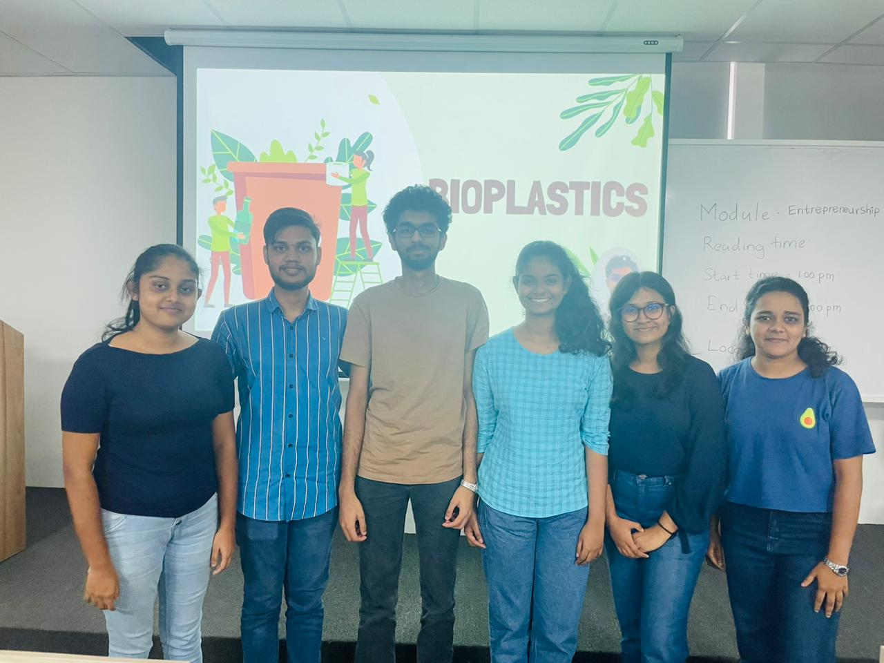

**Assignment Three**

**Talk show on: Ethical aspects of a selected applications**

Get into 7 groups and address the following issues.

|  |  |
| --- | --- |
| **Group no** | **Theme for each group** |
| **1** | **Abortion** |
| **2** | **In vitro Fertilization & Surrogacy** |
| **3** | **Eugenics** |
| **4** | **Genetically modified food** |
| **5** | **Physician Assisted Death** |
| **6** | **Xenotransplantation** |
| **7** | **Aged Care** |

How to conduct a talk show

1. Watch relevant talk show videos

How to gather information

1. Use the ppts which I discussed in the class
2. Use internet- journal articles
3. Watch videos

Talk show

Select the host from each group within the group.

**Host’s role**

Brief about the topic- what will audience hear under this topic

Introduce each member (by their pretended position and their real name) to the audience.

Start asking questions from each member.

Each member should pretend as a Professor or CEO of an organization.

Each member should give valuable information about the **ethical issues of the selected topic**.(3 minutes). Members can give information agreeing or against. Some members can be agreeing, and some members can be against. There can even be arguments.

Audience (2 members) should ask questions. Group get marks for the answers.

There should be a time keeper. Will ring the bell after 2.5 minutes.

Attire, Black and white, can ware a jacket.

Add the individual and group photos and the summary (your part spoken) of your talk show to your portfolio.

**Date of the debate- 05th January 2024**

**objectives**

* To make aware of the ethical issues in the selected applications. helps to improve communication and public speaking skills. Gain confidence in expressing ideas and opinions. Learn to engage and entertain an audience. Collaborate effectively as a team. Network with professionals in your field. Showcase creativity and personality.

**Summary**

* We divided our talk show into two rounds and We talk about aged care abuse in first round and human rights in second round. My role was a lawyer in this talk show and in first round I talk about an aged care abuse case. In second round I talk about the laws that helps for aged induvial and care givers. We got very good complements for this talk show from our judges. I got 85.5% marks for this talk show.

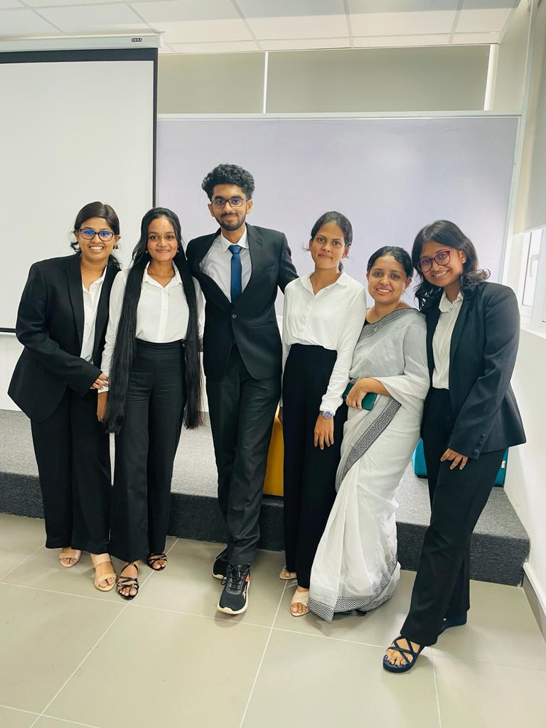

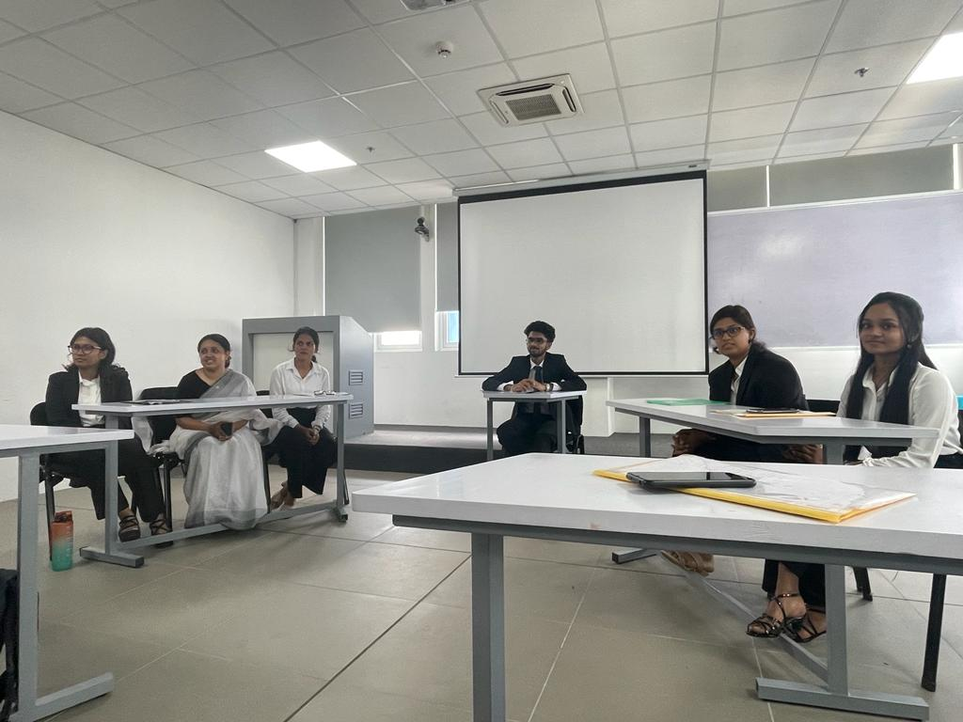

**Assignment Four**

**Resume and Cover letter**

Carrer opportunities:

Universities

* Instructor
* Assistant Lecturer

Other

* Research Assistants
* Research technicians
* Laboratory Technicians
* Clinical Research Assistant
* Biological Technician
* Food research Assistant
* Microbiology research Assistant

There are many more---

**Resume**: 2 - page resume.

This resume is the one which you will be sending to the Human Resources (HR) department of a selected organization showing your interest to the advertisement they have published in a newspaper regarding the career opportunity available for a fresh graduate.

**Cover letter**

Apply information given by Prof. Colin’s lecture

You can check templates from the internet.

**Objectives**

* Showcase my communication and writing skills. Tailor my application to specific job requirements. Highlight my relevant experiences and achievements. Demonstrate my professionalism and attention to detail. Practice self-promotion and marketing of my skills. Receive constructive feedback for improvement. Understand the importance of personal branding. Gain insight into the hiring process from an employer's perspective. Prepare for future job applications and interviews. Boost our confidence in presenting ourselves effectively to potential employers. I got 72.5% marks for this assignment.

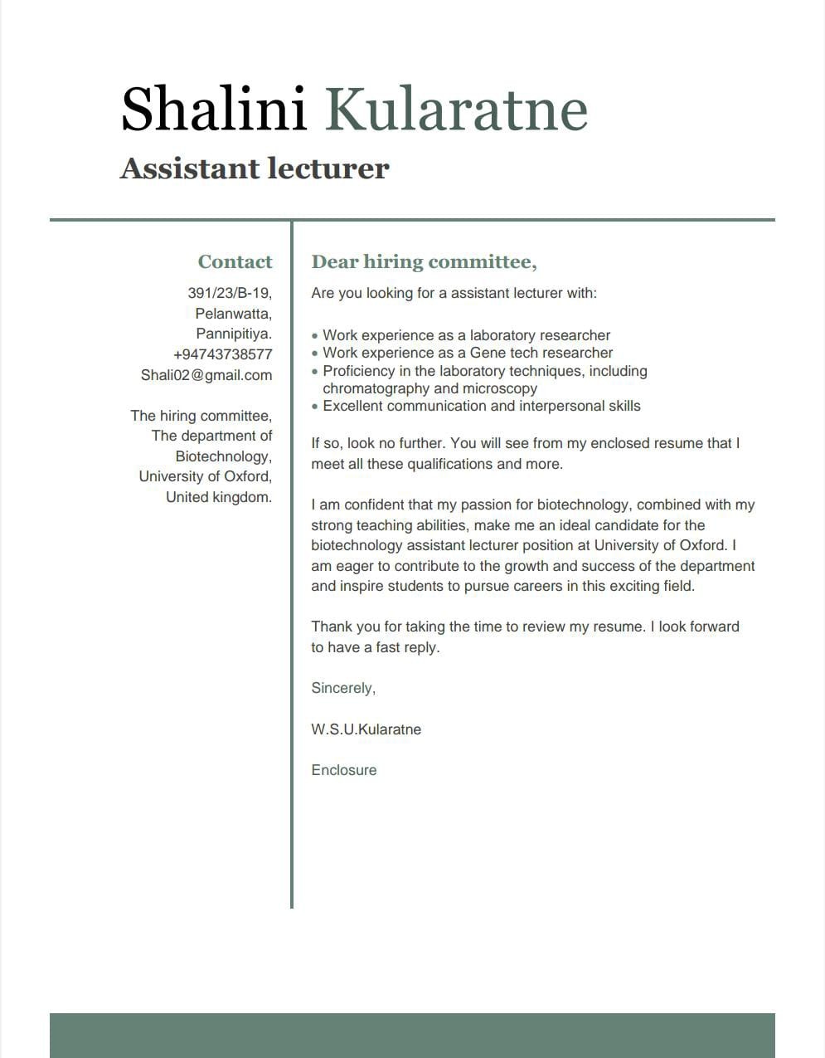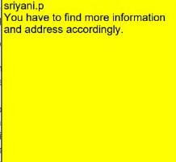

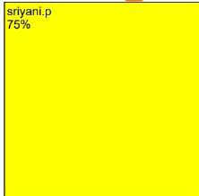**Cover letter**

**Resume**

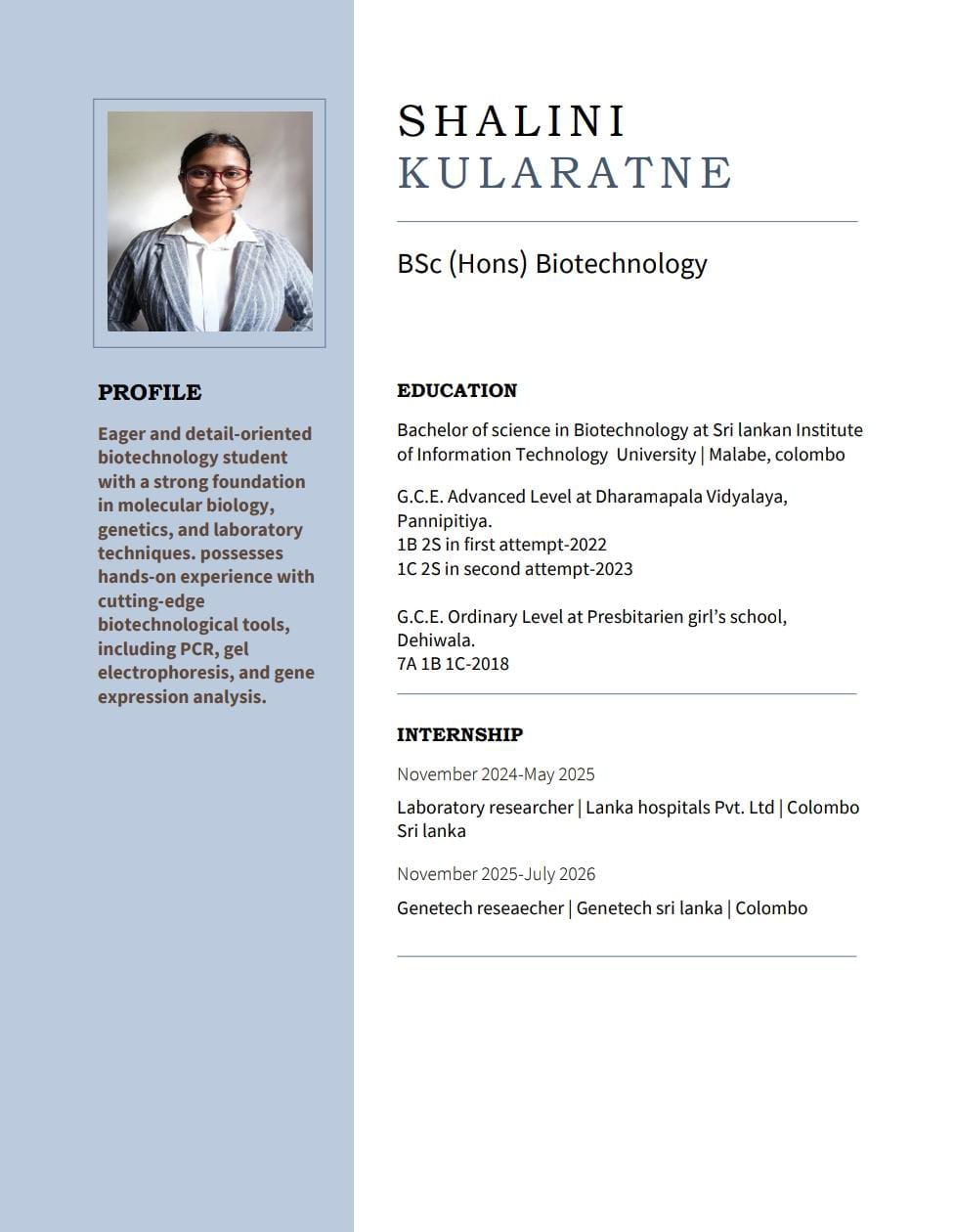

**Deadline to submit the document to the courseweb: 12.01.2024**

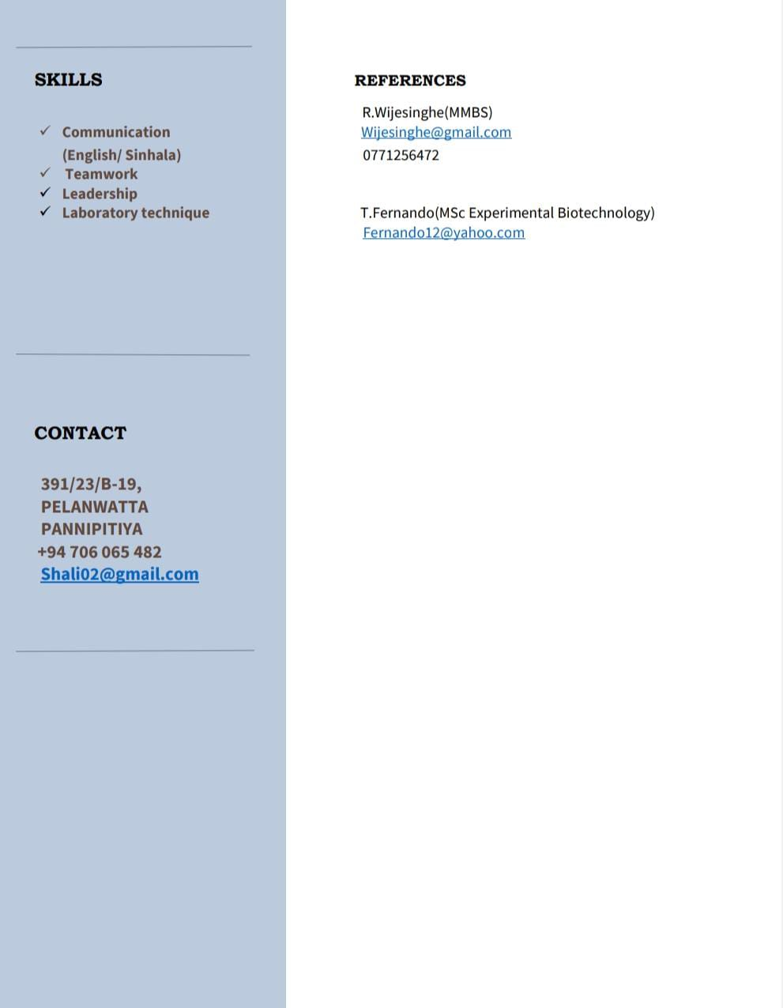

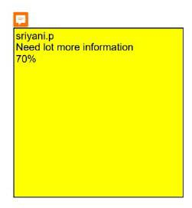

**Assignment Five**

**Career Trajectory**

Objective: To understand career opportunities in Biotechnology and to develop a career

trajectory to achieve the highest position

* Presentation on the career trajectory of a role model in the biotechnology or related industry
* Presentation of your own career trajectory

This is an individual assignment

1. Decide your career in Biotechnology when you graduated.

1. Select a role model related to your career to be in Biotechnology or related area.
2. Study the biography of that person
3. Pay attention to how this person achieved the highest position
4. Develop a presentation using the role model’s strategies

* Your role model’s career trajectory 2 minutes
* Your own career trajectory 3 minutes

1. Presentation is 5 minutes per student

Add presentation slides into the portfolio

**Presentation date: 19.01.2024**

**Objectives**

* It helps to Clarify my goals and aspirations. Receive feedback and advice from others. Practice public speaking and communication skills. Gain confidence in articulating my career plans. Showcase my passion and enthusiasm for my field. Receive guidance on potential opportunities and challenges. Build a professional and supportive network. Gain insights into different career paths and options. Inspire others and potentially attract opportunities through my presentation. I got 78.5% marks for my presentation.

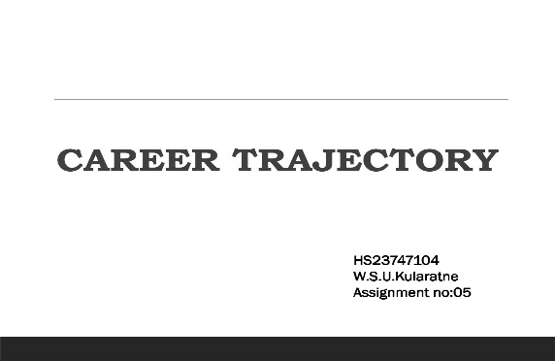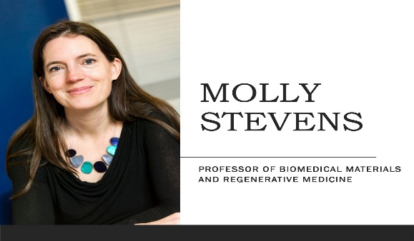

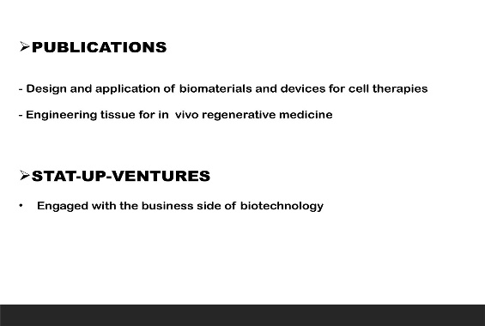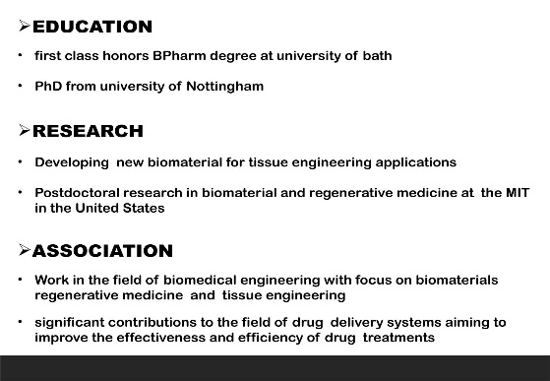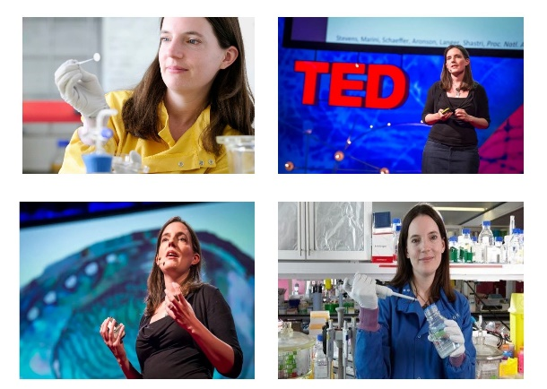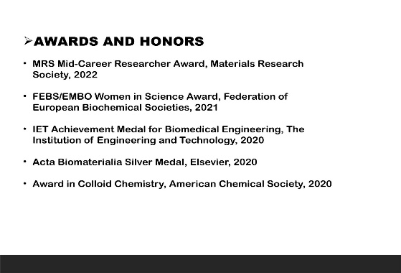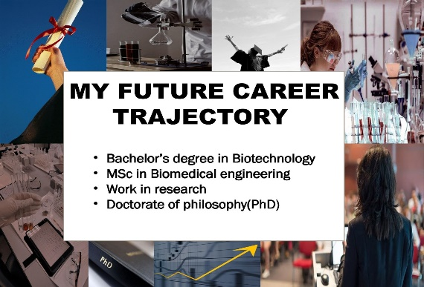

**Assignment Six**

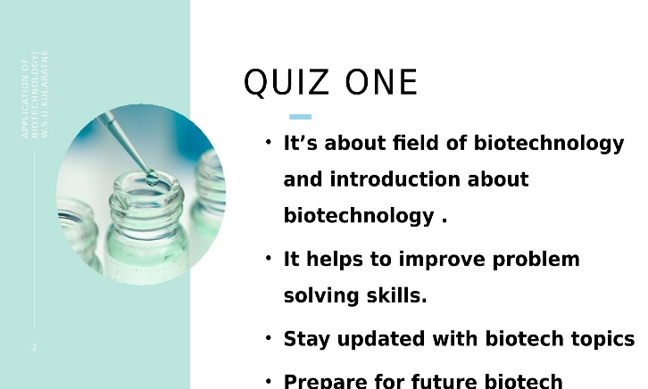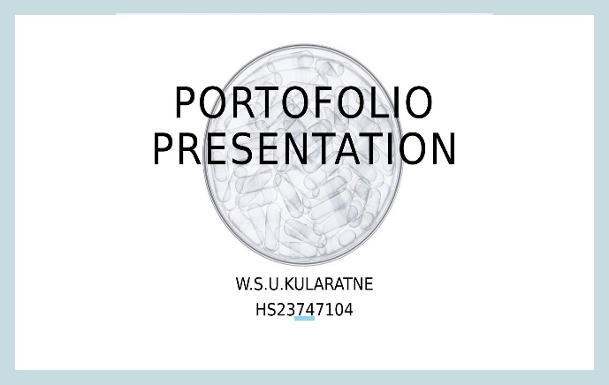

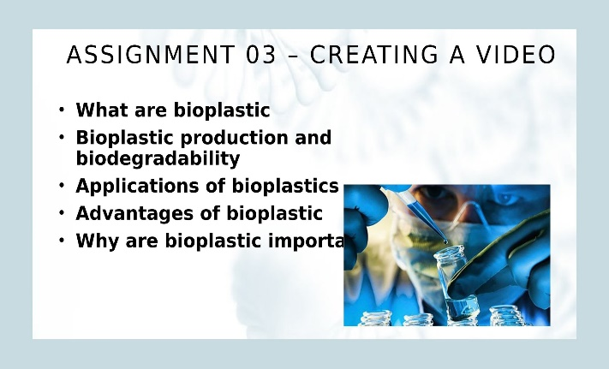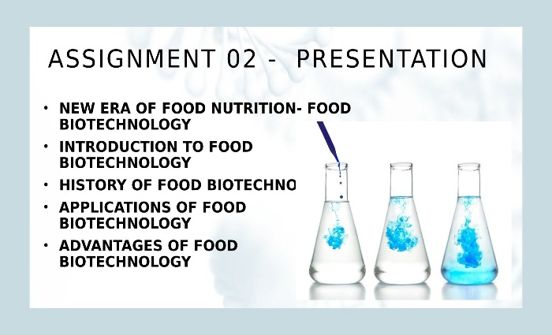

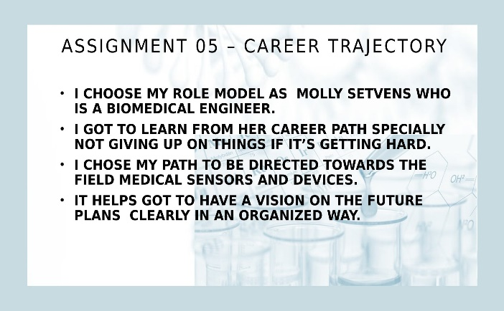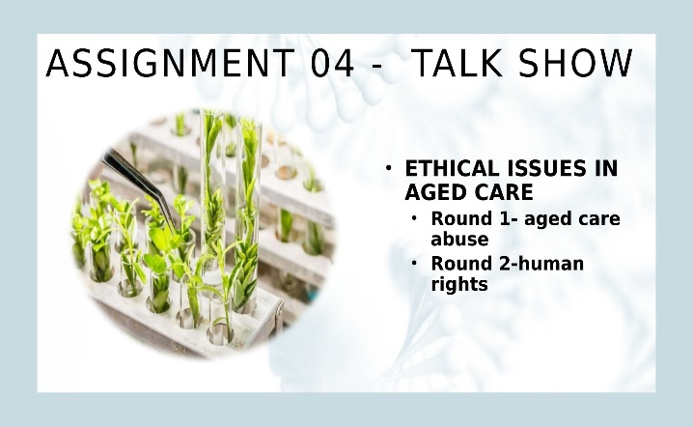

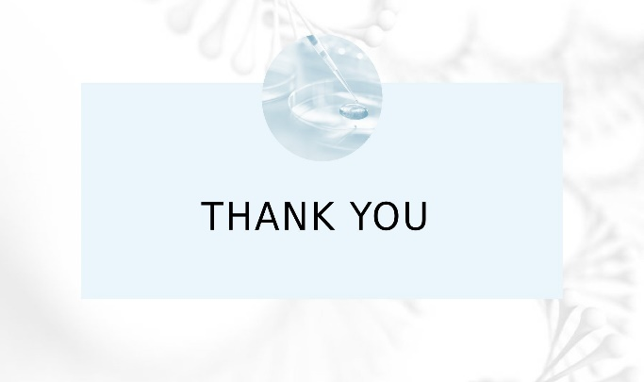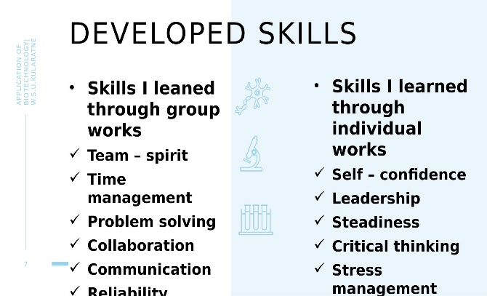

Reflection

Journey through this module was an exciting adventure. It's heartening to see how each unique assignment has contributed to my growth in soft skills and knowledge. It's fantastic that I have honed your presentation skills and prepared for future job opportunities. Our professor, Sriyani E. Peiris, is a wonderful guide, helping us to develop valuable qualities. My improved skills in teamwork, coordination, critical thinking, and problem-solving through group activities are commendable. Personally, I have grown more confident and emerged as a good leader, listener, and communicator. It's inspiring that I am learning from your mistakes and aiming for better. Your enthusiasm for biotechnology and how it's broadened my worldview is truly impressive. This portfolio appears to be a mirror of my observations, research, and experiences, highlighting my strengths and areas for improvement.

……